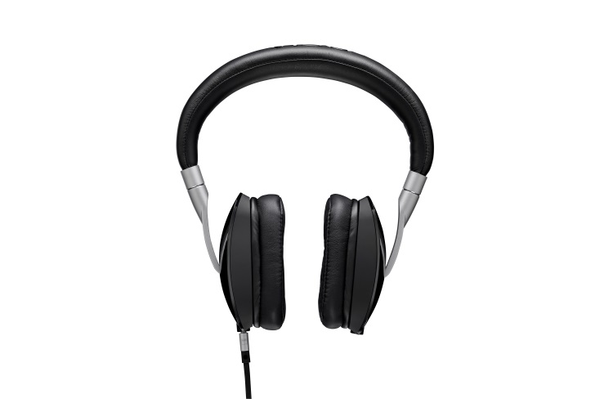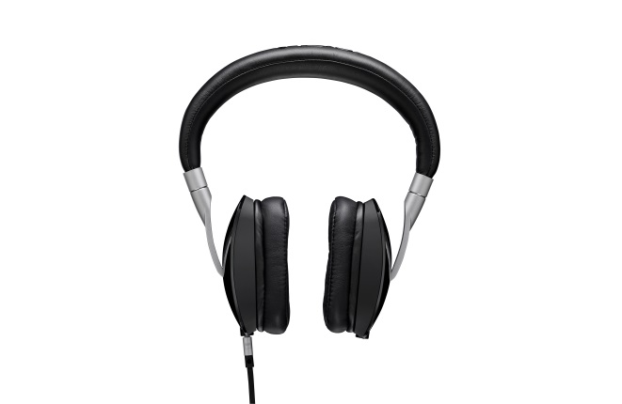

YES

YES

YES

YES

NO

NO

NO

NO

Trying to decide if you should have your devices out and headphones in? It’s simple. Follow the chart above!

Ask yourself the questions in ORDER. Any NO answer means that you can NOT have in your headphones. If you get a YES to one of the questions, continue with the questions until you reach the end.

Failure to comply will result in Disciplinary actions as according to the Departments BYOD policies. Including but not limited to: verbal warnings, loss of privileges, teacher detentions, and Dean Referrals

**Should I have in my Headphones?**